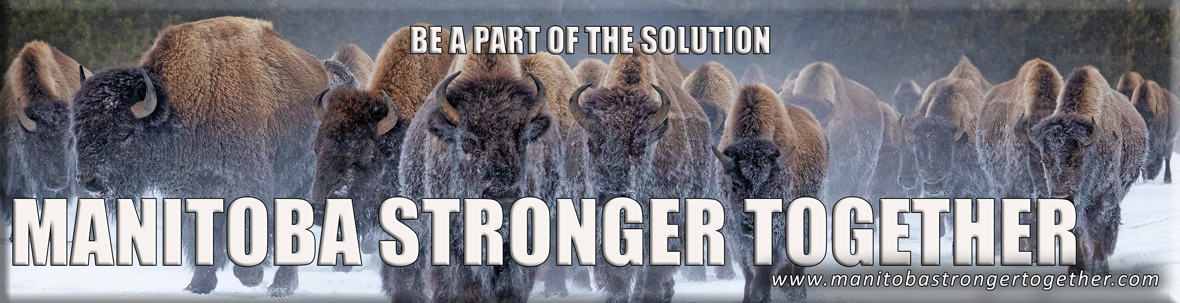Subject: An Introduction to Manitoba Stronger Together

Dear Manitoba Legislator,

We hope this message finds you well. We are writing to introduce you to an organization that is making waves in Manitoba and is committed to strengthening our province: **Manitoba Stronger Together** (MST).

Following the recently held provincial general election we are welcoming members to the Manitoba Legislature, as we believe it's crucial for our elected representatives to connect with the people they serve.

Manitoba Stronger Together (MST) is a diverse and passionate community of Manitobans who share a common commitment to the principles of democracy, individual freedoms, and the prosperity of our province. Our organization serves as a platform for open dialogue, community engagement, and collaborative efforts to address the critical issues facing Manitoba. With members from all walks of life, MST aims to bridge the gap between elected officials and the Manitoban community, fostering understanding and cooperation for the betterment of our great province.

Manitoba Stronger Together (MST) is a non-partisan, grassroots organization created by Manitobans, for Manitobans. We're proud to emphasize that MST operates independently, free from corporate or government funding. Instead, we are funded and fuelled by Manitobans themselves, ensuring our commitment to our principles remains unwavering. Our growing membership, which spans the length and breadth of our province, stands testament to the increasing desire among Manitobans to participate in shaping the future of our great province. With thousands of members and numbers continually growing, MST is a vibrant and inclusive community dedicated to building a stronger, more prosperous Manitoba.

We cordially invite you to join our weekly Zoom meetings, held every Tuesday at 6:30 pm. These gatherings serve as a platform for open discussions on important issues facing our province. We believe your presence and insights would be invaluable in fostering a deeper connection between our elected officials and the Manitoban community.

Additionally, MST is organizing a series of live events in November 2023. These events aim to facilitate constructive dialogues, share ideas, and build a stronger sense of unity among Manitobans. We believe your participation or presentation at one of these events could greatly benefit our shared goal of a stronger and more vibrant Manitoba.

For more information about Manitoba Stronger Together, our upcoming events, and our mission, please visit our website at [https://www.manitobastrongertogether.ca](https://www.manitobastrongertogether.ca/).

If you have any questions or wish to confirm your attendance at a Tuesday Zoom meeting or one of our upcoming events, please do not hesitate to reach out to one of our co-founders, Mr. Ken Drysdale, at [kendrysdale@manitobastrongertogether.ca](mailto:kendrysdale@manitobastrongertogether.ca). Mr. Drysdale would be delighted to assist you in any way.

We look forward to the possibility of your involvement with MST and to working together to make Manitoba an even better place for all its residents.

Thank you for your time and consideration. We are excited about the prospect of collaborating with you to enhance the well-being of Manitobans.

Warm regards,

Manitoba Stronger Together